Create a vm manually:

If want to create by using Openstack: [https://github.com/Clinical-Informatics-Collaborative/socio-economic-data/wiki/6.-Sub‐project-3:-Automation-Deployment-using-Ansible](https://github.com/Clinical-Informatics-Collaborative/socio-economic-data/wiki/6.-Sub%E2%80%90project-3:-Automation-Deployment-using-Ansible)

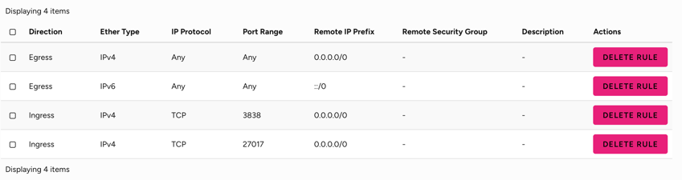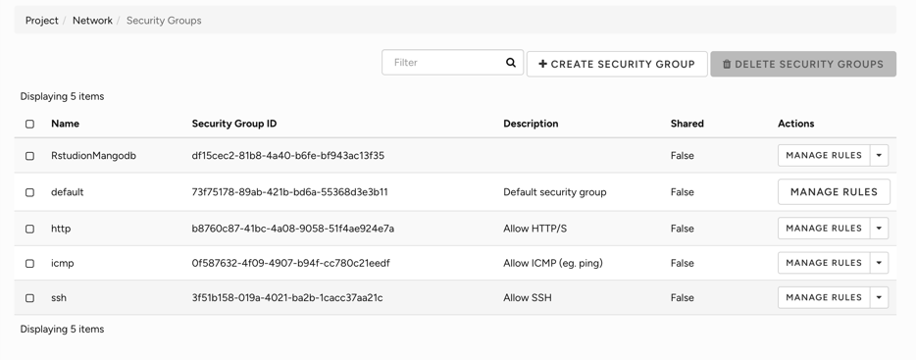

# install mongodb

sudo apt install software-properties-common gnupg apt-transport-https ca-certificates -y

curl -fsSL https://pgp.mongodb.com/server-7.0.asc | sudo gpg -o  
/usr/share/keyrings/mongodb-server-7.0.gpg –dearmor

# add MongoDB 7.0 APT repository to the /etc/apt/sources.list.d directory.

echo "deb [ arch=amd64,arm64 signed-by=/usr/share/keyrings/mongodb-server-7.0.gpg ] https://repo.mongodb.org/apt/ubuntu jammy/mongodb-org/7.0 multiverse" | sudo tee /etc/apt/sources.list.d/mongodb-org-7.0.list

# reload

sudo apt update

# install

sudo apt install mongodb-org -y

# start

sudo systemctl start mongod  
sudo systemctl status mongod （should be active）

# enable MongoDB to start on boot

sudo systemctl enable mongod

# to access mongodb run command

mongosh

# secure mongodb

use admin

db.createUser(

{

user: "AdminCD",

pwd: passwordPrompt(),

roles: [ { role: "userAdminAnyDatabase", db: "admin" }, "readWriteAnyDatabase" ]

}

)

Password： iwannasleep

# set conf file  
sudo nano /etc/mongod.conf

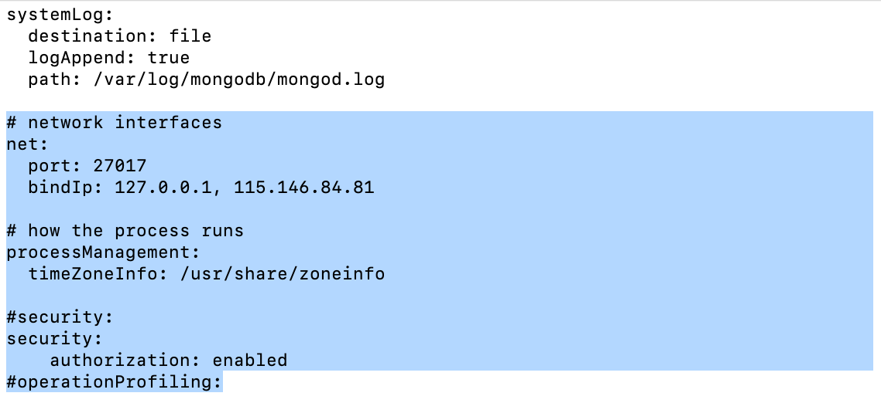

Where the 115.146.84.81 is the Nectar Instance ip

Login as admin：mongosh --username AdminCD --authenticationDatabase admin

Grant to admin:

Use admin

db.grantRolesToUser("AdminCD", [{ role: "dbOwner", db: db_name}])

FYI: https://www.cherryservers.com/blog/install-mongodb-ubuntu-22-04#how-to-install-mongodb-on-ubuntu-2204-step-by-step